

**Faculty of Engineering**

**Department of Civil Engineering**

**Structural Mechanics and Earthquake Engineering Laboratory**



**Structural Mechanics and Earthquake Engineering Laboratory**

**UNIT SUPERVISORS**

**Assist. Prof. Dr. Hakan OZTURK (Earthquake Engineering)**

**Assist. Prof. Dr. Elif AGCAKOCA (Structural Mechanics)**

**BENDING TEST FRAME**

General Information:

Quasi-static bending tests of reinforced concrete or steel beam specimens can be performed on the test setup. It has two hydraulic jacks with a 1000 kN load capacity which can be applied manually or automatically by that jacks. The length of specimens can be between 1-4 m and they can be tested under 3 or 4-point loadings with simple or roller support conditions.

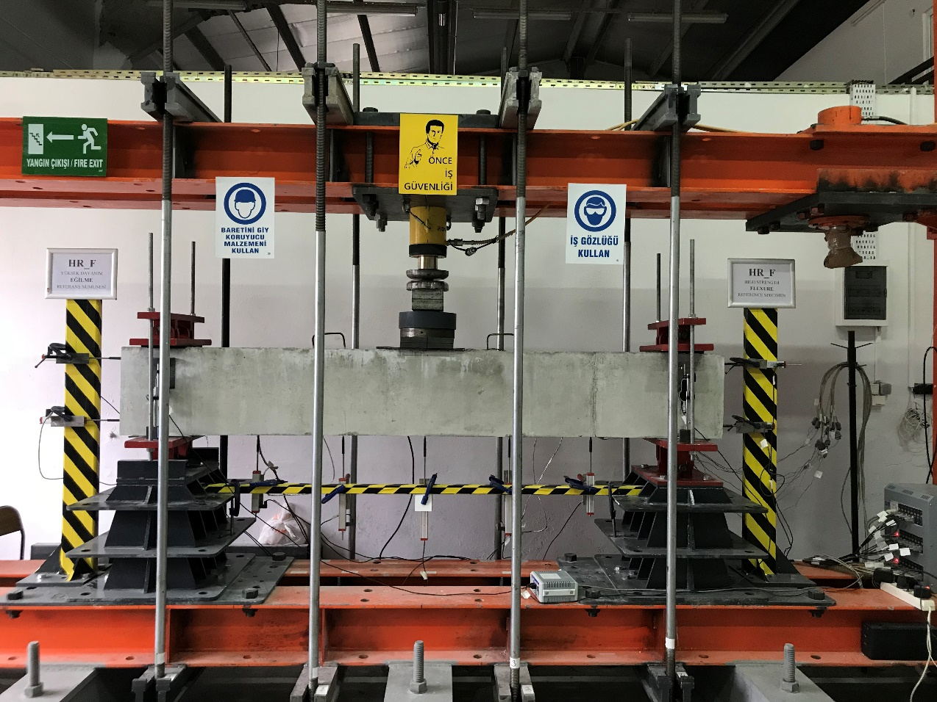

Figure 1. The bending test setup and the data logging system

References: Teknik Destek Grubu and Yuksel Kaya Makina

Technical Properties of Equipment: There is a data logging system having 32 channels to which necessary several different devices for quasi-static tests can be connected. The data recording speed is 8 per second. The applied load (via a load cell), vertical and horizontal displacements (via linear potentiometers or LVDTs), strains (via strain gauges), and crack widths (via linear crack potentiometers) can be recorded.

|  |  |  |  |  |
| --- | --- | --- | --- | --- |
|  |  |  | C:\Users\HP\OneDrive - sakarya.edu.tr\____Demir_PhD\_Experimental\Test Final\Final Test Results\T13 DB60_1.86_SR-C1 16.01.2018\IMG_20180116_144338.jpg |  |

a) Load Cell b) linear potentiometers c) strain gauge d) data logger

Figure 2. Equipment, measurement devices and data logger for quasi-static tests

**Measurement of Applied Load:** the load applied on a specimen can be measured via a load cell with 1000kN measurement capacity.

**Measurement of vertical and horizontal displacements:** vertical and horizontal displacements can be measured via linear potentiometers having different resistances (5k and 10k) and a measurement range between 50-150 mm.

**Measurement of crack widths:** linear potentiometers fixed as pinned supports on specimens perpendicular to expected crack orientation are used to measure any flexural and shear cracks.

**Measurement of strains:** strains on reinforcements or any structural steel elements are measured via strain gauges fixed on those members. The acquisition system is compatible with both FLA and YFLA type strain gauges.

**IMPACT TEST FRAME**

General Information about the test setup:

The specimens produced with different material such as reinforced concrete, steel, timber can be tested under free fall impact load. The test of classic and deep beams can be mainly conducted. However, after making necessary fixation providing and simulating accurate member behavior and support conditions, slabs, columns and frames can be tested in the test testup. Impactor capacity is 10 kN and it can be dropped from maximum 3 m in height (Figure 3). Different type of impactors can be used during tests.

The instruments can be used during tests are demonstrated in Figs 3.a and 3.b. In the figures, load cells (a), laser maters (b) and accelerometers (c) are shown. The crack widths initiated and propagated during loadings can be measured linear potentiometers having pinned restraints. Strains can be measured via strain gauges as well.

|  |  |  |
| --- | --- | --- |
| CARPMA TESTI CİHAZI 3-Model |  | |
| Figure 3.a. Test setup and measurement devices. | | |
| F:\OneDrive - sakarya.edu.tr\DOKTORA\Doktora Deneyleri\2. Aşama-Çarpma Deneyleri\05132018_063659_H_F_E1\Resim ve Video\IMG_5099.JPG | | |
| Figure 3.b. Measurement of crack widths | | |
|  | |  | |
| Şekil 4. The details of impactors | | | |

References: NI Instrument, DTA Engineering, Enovas Engineering

The data during test can be acquired via a 32-channel dynamic data acquisition system with 25 kHz. All measurement devices can be connected to that data logger.

|  |  |  |
| --- | --- | --- |
| |  | | --- | | a) İvmeölçer b) Straingaguge c) NI 9219 d) NI 9234 e) NI 9237 f)Tam-Çeyrek Köprü g) NI cDAQ | | NI9215 C:\Users\Sakarya Üniversitesi\Desktop\DV001_666px_PPIC_ODS9_M12_R.jpg  h)Yük hücresi j) NI 9215 k) Lazermetre | |

Şekil 5. Kullanılacak sarf malzeme ve cihazlar

**WALL TEST FRAME**

General Information:

Masonry wall having 1x1 m dimensions can be tested under a quasi-station loading. The load capacity of the frame is 1000 kN.

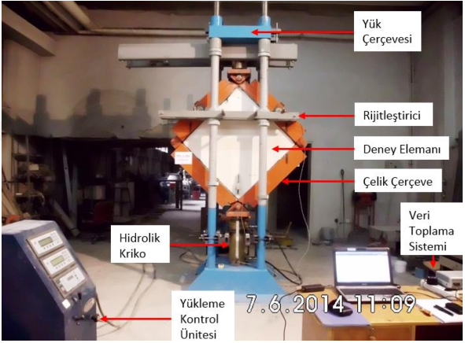

Reference: A. Cumhur, “Strengthening of brick infilled walls with expanded steel plates”, PhD thesis, Sakarya University, Institute of Natural Sciences, 2016

**ONE DIRECTIONAL (DOF) SHAKE TABLE**

General information:

One directional dynamic load such as earthquake, sine, cosine etc. having different frequency, amplitude and characteristics can be simulated on the test setup. Maximum displacement capacity is ±190 mm. The setup has 250 N specimen weight capacity and can create maximum ±2 g in acceleration. Its dimension is 1x1 m as well.

The setup has a data logger having 4 channels can acquire dynamic data with 1 kHz sensitivity. Moreover, there are 3 one directional accelerometers which is compatible with the test setup. The accelerometers have a 5 mikro-g/Hz noise performance, ±3 g measurement capacity and 0-400 Hz frequency range (Fig. 6).

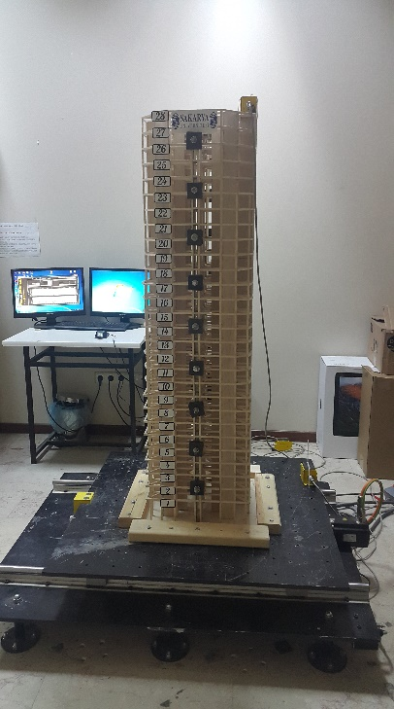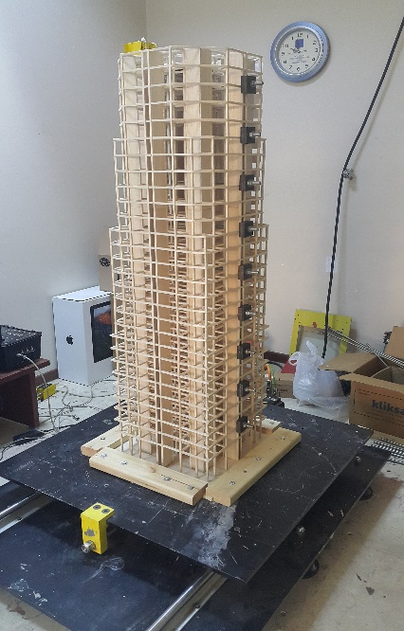

Figure 6. Test setup, data logger and measurement devices

Reference: TDT Scientific Measurement Group

**6 DIRECTIONAL (DOFs) SHAKE TABLE**

General Information:

SANLAB SMotion3000 is 2.5x2.5 m in dimension and 6 degrees of freedom and has 15 kN load capacity (Fig. 7). It has a build-in software for control system to simulate every kind of sinusoidal and earthquake loads.

|  |  |
| --- | --- |
|  | D:\Tubitak_proje_son\Deney Düzeneği resimler\sarsma tablası görünüm.JPG |

Figure 7. Test setup.

Reference: SANLAB Simulation

Technical Properties:

Maximum displacement, acceleration and velocity capacities of the shake table are reported in Table 1.

Table 1. Motion limits of the shake table

|  |  |  |  |
| --- | --- | --- | --- |
|  | **Position / Rotation** | **Velocity / Angular velocity** | **Acceleration / Angular acceleration** |
| **Surge** | ± 0.34 m | ± 0.7 m/s | ± 6 m/s2 |
| **Sway** | ± 0.33 m | ± 0.7 m/s | ± 6 m/s2 |
| **Heave** | ± 0.34 m | ± 0.55 m/s | ± 8 m/s2 |
| **Roll** | ± 18 ° | ± 33°/s | ± 220 °/s2 |
| **Pitch** | ± 18 ° | ± 34°/s | ± 220 °/s2 |
| **Yaw** | ± 24 ° | ± 33°/s | ± 300 °/s2 |